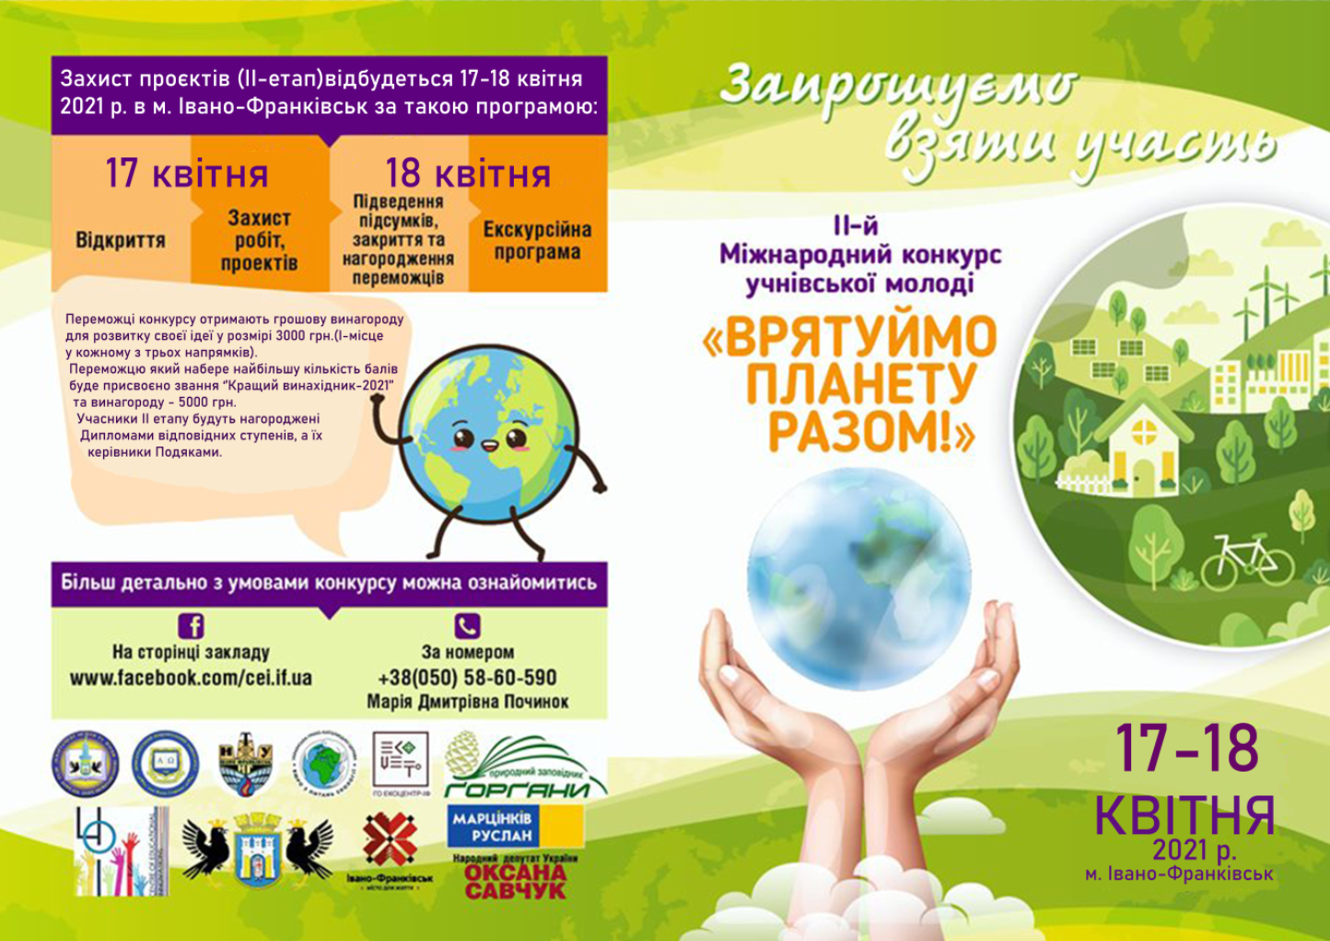

THE INTERNATIONAL CONTEST
FOR SECONDARY AND HIGH SCHOOL STUDENTS

"LET US SAVE OUR PLANET TOGETHER!"

the Centre for Educational Innovations, Ivano-Frankivsk, Ukraine

the Department of Education and Science, Ivano-Frankivsk, Ukraine

The Ivano-Frankivsk Centre for Educational Innovations

is honoured to announce a call for participation in the International contest

"LET US SAVE OUR PLANET TOGETHER!"

that will be held in Ivano-Frankivsk, Ukraine from March 15 to April 18, 2021.

HOST INSTITUTION ADDRESS:

Address: | Ivano-Frankivsk Centre for Educational Innovations, 36 Nazalezhnist Street, Ivano-Frankivsk, 76018, Ukraine
Tel.: | (+38) 0342586022, +(38) 0 98 785 1992; +(38)0 68 933 4992
e-mail: | cei.if.ua@gmail.com
Web site | https://cei.if.ua/

General information ABOUT THE CONTEST

This Regulation defines the procedure for holding the International Contest among young people "Let's Save the Planet Together!" (hereinafter – the Contest.)

The Contest is held annually on a voluntary basis and is open to students of general secondary education, extracurricular and vocational education aged 13-18.
This Inernational Contest is a unique event that brings school students, industry, government, and academia together in the search for improved solutions to challenges. The Contest occurs in April and draws students from around Ukraine and the world to showcase engineering design solutions.
This event is important for educating an ly conscious generation able to solve their local and regional problems, drawing up plans for the development and rational use of natural resources, creating space for talented people, financial support for their further research
School students are supposed to design solutions for real-world problems and develop fully operational bench-scale models of their technologies.
Then they communicate their work through a conference-style poster and both written and oral presentations, which they showcase along with the bench scale model before a panel of professionals who judge the contest.
School students hone their skills while solving challenging real-world problems. Their solutions are judged by academic and engineering professionals through research papers, oral presentations, and bench-scale demonstrations.
The rigorous requirements of the contest help develop students’ entrepreneurial mindset in design .

GOALS AND OBJECTIVES
The global goals:
- to spot young, talented people between the ages of 13 and 17 and support their ideas to save the environment;
- to inspire young people in Ukraine and around the world to develop innovative ways to tackle the issues that matter to them.

Objectives:
- to promote STEM education as a way to bring 21st century skills into the classroom and foster in young learners a long-term interest in these subjects; to develop their science, technology, engineering and mathematics skills through solving practical, real world problems; to promote critical thinking, problem solving, collaboration and perseverance; skills that are useful throughout their lives;
- to support young inventors and provide opportunities for the implementation of the best research projects;
- to develop outlook, competence and foundations of rational use of natural resources;
- to raise awareness and ecological consciousness;
- to identify talented young people and involve them in research, support and promote would-be researchers for high-tech industries in Ukraine;
- to promote their career awareness, to help navigate their occupational options to choose and train for jobs that suit your personality, skills, and interests;
- to identify the best young inventor and award the title of "Inventor of the Year".

ELIGIBILITY FOR PARTICIPATION
School students from all over Ukraine and other countries in grade 6 to 12 who are between 13 and 17 years of age are eligible to participate; each participating student is limited to one entry.
Each contestant prepares written, oral, poster, and bench-scale model presentations in response to urgent tasks.
Each contestant should have an adviser (a school teacher or university professor) and/or co-adviser (from any institution that advised on the project).
The contestant’s personal data will be processed according to the Data Protection Law.

CONTEST REQUIREMENTS AND PARTICIPATION CRITERIA
- Focus:
- research; scienсe and technology, IT-engineering;
- ecology, biotechnology; social studies;
- arts; design and architecture.

Contest aligns with the following requirement: the tasks should be challenging multi-month projects requiring a student to design and demonstrate functionality of a real-world complex system.

Student Outcomes:
- an ability to identify, formulate, and solve complex engineering problems by applying principles of engineering, science, and mathematics
- an ability to apply engineering design to produce solutions that meet specified needs with consideration of public health, safety, and welfare, as well as global, cultural, social, , and economic factors
- an ability to communicate effectively with a range of audiences
- an ability to recognize ethical and professional responsibilities in engineering situations and make informed judgments, which must consider the impact of engineering solutions in global, economic, and societal contexts
- an ability to function effectively on a team whose members together provide leadership, create a collaborative and inclusive environment, establish goals, plan tasks, and meet objectives
- an ability to develop and conduct appropriate experimentation, analyze and interpret data, and use engineering judgment to draw conclusions
- an ability to acquire and apply new knowledge as needed, using appropriate learning strategies.

THE JUDGING PROCESS and WINNER SELECTION

Your Entry will be judged in one of two sections. A Judging Panel will review and select the entries submitted. Entries will be judged based on their competition groups as determined by the judges. There are two rounds of judging. The first round of judging occurs when the participant’s project is reviewed by a panel of judges. The finalists will make online presentations.
The Criteria and maximum score for each entry section is as below:

Judging criteria
General judging criteria include: process feasibility and practicality, cost analysis, community relations and outreach, adherence to various applicable regulations and permitting, safety considerations, and a discussion of potential waste streams, etc.

WRITTEN REPORT

Judges’ Scoring Rubric:

summary, basis for design, equipment and process selection, depth of research, laboratory evaluation, testing, discussion of legal implications, economic analysis and/or cost benefit discussion, professional audits/public involvement, overall quality/succinctness, clarity of communication.
- Summary includes engineering basis for design and summary of results.
- Equipment and process selection based on in-depth research of process and equipment.
- Discussion of lab evaluation, testing, process monitoring, and waste generation.
- Discussion of legal, health, and safety (worker and public) implications for the entire process.
- Economic analysis and/or cost/benefit discussion.
- Professional audits/public involvement.
- Overall quality: grammar, organization, succinctness.
- Timely/Late Submission

Bench-Scale Demonstration

General Judging Criteria

effectiveness and overall performance, originality, craftsmanship, completeness, safety, and public health considerations, waste generation, cost effectiveness, scalability, processing time, ease of use, reliability, communication and ability to answer questions
- Functionality, yield and overall performance
- Bench-scale process operation safety
- Waste generation, recovery and stability (where applicable)
- Originality and completeness of the bench scale
- Repeatability, accuracy and reproducibility of bench scale
- Cost of and suitability of bench-scale construction

ORAL PRESENTATION

Oral Presentation Guidelines and Judging Criteria

completeness of presentation, inclusion of key sections, effectiveness, team participation, audio-visual materials, and ability to answer questions
Regulations and Logistics
- Presentation Time Limit: 10 minutes
- Question/Answer period: 10 minutes
- Setup and breakdown time: total of 5 minutes
- Point deductions: points deducted per minute over the Presentation Time Limit
- Media: PowerPoint presentations must be on the contestant’s computer. The computer will be plugged into the AV system at the venue.
- Primary Audience: Judges who, acting as potential client, will decide if your designs are technically, logistically, and economically viable.
- Secondary Audience: Contestants from otherthe participating schools.
- Videotaping: Is not allowed.
- Dress: Business attire (Dress for Success!)
- Goal: Convincing your client (a.k.a. the judges) that yours is the optimal solution for the task.
- Introduction: Introduce yourself and your work briefly to the judges at the beginning of the presentation.
- Conclusions: End the presentation with a discussion of conclusions. Finally, ask the audience if they have questions.
Preparation:
- Prepare a confident, technical and business-like discussion of your solution.
- Include all essential elements from the body of the written report .
- Include citations at the bottom of each slide.
- Use graphs, charts and figures to illustrate trends and findings.
- Be concise. The judges have already read the report. Point out only the most important points.
- Anticipate questions: The judges, like a manager or client, will usually identify a weak area in your logic or presentation and probe it. If you do not know the answer, do not bluff. Promise to look it up and discuss it during the bench-scale demos on the following day.

General Judging Criteria
- Overall quality, completeness, level of research and discussion of results
- Justification and advantages of the proposed project
- Process flow sheet, material balance and safety discussion
- Realism of cost estimates
- Ability to answer judges’ questions
- Delivery and effectiveness of presentation

POSTER PRESENTATION

General Judging Criteria

effectiveness, graphic impact, presentation, completeness, and ability to answer questions
- Conciseness and clarity of the poster
- Completeness of the poster
- Team’s knowledge of the subject
- Overall Impression
Points
Criteria |  |  | Points
 | Relevance of the project topic, elements of scientific novelty | Significant, compliance of the project topic with the modern needs of a certain field of science and prospects for its development, practical tasks of the relevant field | 0- the relevance of the topic is not justified;  6- partial disclosure of the relevance of the topic;  8- novelty is not scientifically proved;  10- the work is characterized by scientific novelty;
 | Validity of the results obtained | The recent scientifically substantiated results are obtained, which together solve a specific problem and allow to create the necessary invention | 0 - no valid results;  6 - partially noticeable result;  8 - the result is available, but not scientifically substantiated;  10 - the scientifical result is scientifically substantiated
 | Focus on results | Sustainability of the research formula: substantiation of the relevance of the topic of the work, its connection with the object and subject of research; semantic correspondence of the purpose, tasks and constructive conclusions | 0 - the structure of the work does not meet the goals and objectives of the study, the object and subject of the study are not identified or do not correspond to the topic;  6 - the structure of the work partially meets the goals and objectives, the relevance of the topic is presented as a statement, the formula of the work is not fully maintained;  8 - the structure of the work as a whole is logical, the formulation of the subject, purpose, objectives, conclusions have insignificant shortcomings;  10 - structure is logical, mutually agreed wording of the subject, purpose, objectives, conclusions, relevance is proven
 | Structure of the presentation | Use, quality and expediency of preparation of illustrative materials, mastery of the content and culture of the presentation | 0 – visual materials are not used;  6 - visual materials of low quality, in the organization of the presentation there is uncertainty;  8 - the presentation is well organized, the report is supplemented with visual materials, which are not always referred to in the report;  10 - the presentation is well organized, the report is accompanied by meaningful visual materials
 | Project quality | Conformity of the project structure, orientation on results | 0 – the structure of the project does not correspond to its title;  6 - the structure of the project partially corresponds to the title, the relevance of the topic is presented as a statement;  8 - the structure of the project as a whole is logical, the wording of the titles of sections have insignificant substantive or editorial shortcomings;  10 - the structure of the project is logical, mutually agreed wording of the object, purpose, objectives, conclusions, relevance is proven

JUDGES

Judges are:
- Volunteers who attend the contest for four days and provide their own transportation and lodging.
- People who have worked in fields as scientists, engineers, regulatory, and/or public relations liaisons.
- People who want to encourage future engineers and introduce them to new ideas and new ways of thinking

AWARDS
All participants who will finalize their submissions and do it on time before the deadline will get a certificate of participation where a name of a registered participant, a school and country will be specified. All participating students are eligible for the Award Recipients.
The participants of the second stage of the Contest will be awarded cash prizes – 3000 UAH.
The Best Inventor of the Year will be awarded 5000 UAH.
Other outstanding students will receive various presents, diplomas and certificates. Their supervisors will be awarded Certificates of Merit.

IMPORTANT DATES

 | Steps | Dates
 | STAGE I – OFF-SITE
 | Call for participation | March 15, 2021
 | Registration opens
 | Each participant should send to the Centre for Educational Innovations (cei.if.ua@gmail.com):  - an application form;  - an online profile;  - description of the project/invention (10 pages);  - Power Point presentation (10 slides) | March 15, 2021 – April 15, 2021
 | Name the files as follows: bibik_proekt; bibik_zajavka, bibik_prezentatsiya
 | - Each Advisor and Co-Advisor should complete an application form and an online profile.
 | Registration closes | April 15, 2021
 | Research work manuscript submission | April 15, 2021
 | Preliminary Report on the winners of Stage I:  https://www.facebook.com/cei.if.ua/  https://cei.if.ua/ | April 16, 2021
 | STAGE 2 – ON-SITE / on-line
 | Welcome Ceremony, Dinner, and Safety Meeting Mandatory | April 17, 2021
 | Project Presentation | April 17, 2021
 | Closing Ceremony, awards ceremony | April 18, 2021
 | Social program | April 18, 2021

Додаток 1  до Положення  про Міжнародний конкурс  «Врятуймо планету разом!» | Appendix 1  to the Guidelines on the International Contest  "Let Us Save Our Planet Together!"
ЗАЯВКА НА УЧАСТЬ  У МІЖНАРОДНОМУ КОНКУРСІ  «ВРЯТУЙМО ПЛАНЕТУ РАЗОМ!» | Application form  for the International Contest  "Let Us Save Our Planet Together!"

Інформація про учасника / Information about the contestant
 | Прізвище
 | Last name
 | Ім’я та по-батькові
 | Given name(s)
 | Дата народження (день, місяць, рік)
 | Date of birth (day, month, year)
 | Місце навчання:
 | Institution affiliation:
 | Клас
 | Grade
 | Назва номінації
 | Nomination title
 | Напрям дослідження
 | Field of research
 | Назва наукової роботи
 | Research project title
 | Адреса електронної пошти | E-mail:
 | Контактний телефон | Tel.:
 | Необхідні умови для демонстрації
 | Technical aids for the presentation

Інформація про керівника /
Information about the superbisor/advisor

 | Прізвище
 | Last name
 | Ім’я та по-батькові:
 | Given name(s)
 | Місце роботи:
 | Place of employment
 | Посада
 | Post tittle
 | Навчальний заклад, який відряджає
 | Institution affiliation
 | Електронна пошта | E-mail:
 | Контактний телефон | Tel.:

Send an application form, a summary, and a Power Point presentation to the Centre for Educational Innovations: cei.if.ua@gmail.com

Своїм підписом засвідчую достовірність викладеної мною у цій заявці інформації. З умовами участі у Міжнародному конкурсі «Врятуймо планету разом!» ознайомлений (-на). | I, the undersigned, hereby confirm that all information specified herein is true.  I declare that I have read the conditions of participation in the International Contest "Let Us Save our Planet Together!"
(день, місяць, рік / day, month, year) | (підпис учасника / contestant’s signature)
 | (підпис керівника / adviser’s signature)

Appendix 2
to the Guidelines on the International Contest
"Let Us Save Our Planet Together!"

requirements
for the research paper submitted for the International Contest
"Let Us Save Our Planet Together!"

Length | 10 pages , formatted according to the requirements
File type and name | DOC or DOCX format (Microsoft Office Word), maximum file size – 3 mb;  File name: for manuscript – last name_ robota (smith_robota); for application – last name_ zajavka (smith_zajavka).
Language | Ukrainian, English, German, French, Czech, Polish, Romanian
Abstract – in English (and Ukrainian), the main text in Ukrainian, English, German, French, Czech, Polish, Romanian.
Make sure that your text has been spell and grammar checked before submission.
Use italics for any foreign language text in the manuscript body.
Font | Times New Roman 14 pt, regular; headers – upper case, bold type, centered
Spacing | line spacing – 1,5; (including bibliography, any notes, citations, figures, and tables); spacing before – 0; spacing after – 0
Layout | Paper size – A4; orientation – portrait; margins: left – 2,5 cm, top, bottom, right – 1,5 cm each; text alignment – justified (the main text – right aligned; headers – center aligned); paragraph alignment against left margin – 1,25;  Begin chapters on new pages. Center the chapter title, even if it’s only Chapter One (or Chapter 1), about one-third of the way down the page. Skip a couple of spaces and begin the text of the chapter.  Remove running heads on pages.
Content organization length | - Title Page – 1 page;  - Abstract – 1 page;  - Abbreviations, notations, symbols, units – 1 page;  - A table of contents – 1 page;  - Introduction (with explanation of relevance and novelty of project) – 2 pages;  - Literature review – 5 pages;  - Materials and methods – 4 pages (indicating the object and purpose of the study);  - Results and discussions – 3 -10 pages;  - Conclusions – 1- 3 pages;  - References – List of sources used (in an arbitrary order according to the new rules for the use of references) – 1 2 pages. (20-25 reference sources).  Appendixes (if applicable)
Title page | - Institution that the contestant represent  - Focus (in accordance with these Regulations)  - Title (Capitalize all words, including prepositions that are more than four letters long.)  - Contestant’s given and last names; contestant’s status (e.g. Middle school student, grade 7)  - Adviser’s given and last names; job title, qualification degree title, honour title  - Co-adviser’s given and last names; job title, qualification degree title, honour title (not obligatory)  - institutional affiliation of the authors, contestant and supervisor’s contact information
Abstract | one-paragraph summary of the entire study – no more than 250 words in length.
Introduction | a section which describes the topic under investigation, summarizes or discusses relevant prior research, identifies unresolved issues that the current research will address, and provides an overview of the research that is to be described in greater detail in the sections to follow.
Methods | a section which details how the research was performed. It typically features a description of the participants/subjects that were involved, the study design, the materials that were used, and the study procedure. If there were multiple experiments, then each experiment may require a separate Methods section.
Results | a section which describes the data that was collected and the results of any statistical tests that were performed. It may also be prefaced by a description of the analysis procedure that was used. If there were multiple experiments, then each experiment may require a separate Results section. It includes calculations, budget, etc.
Discussion | commonly features a summary of the results that were obtained in the study, describes how those results address the topic under investigation and/or the issues that the research was designed to address, and may expand upon the implications of those findings and sustainability of the project. Limitations and directions for future research are also commonly addressed.
References | a list of articles and any books cited – an alphabetized list of the sources that are cited in the paper (by last name of the first author of each source).
Appendix | supplementary information (optional) – in some cases, additional information that is not critical to understanding the research paper, such as a list of experiment stimuli, details of a secondary analysis, or programming code, is provided.
- You may use graphs, tables, figures in such sections as “Materials and methods”, “Results and discussions” and “Appendixes ”
- Appendices should be mentioned in the body of the text.
- Each Appendix should be labeled with a letter, except when there is only one Appendix.
- Each Appendix should have a title, which is not italicized; headings within the body of the Appendix are in italics.
- Capitalize any word 4 letters or longer (regardless of part of speech) occurring in the title, headings, and captions.
Tables and/or Figures | graphs and data (optional in some cases) – depending on the type of research being performed.
- Tables and figures are inserted directly into the text and should appear after they are mentioned in the text.
- Introduce as “TABLE/FIGURE #”, followed on the next line by the title, in which all words longer than four letters are capitalized. There is no period at the end of the title.
- All abbreviations in tables must have definitions provided so that the table is readable without the accompanying text.
- All tables and figures should be in black and white or gray scale.
- All tables and figures should be in Word format. No images of any kind.

Note 1. It is advisable that the body of the paper include:
- Full-scale design description
- Technical evaluation
- Bench-scale/prototype design and performance (test data)
- Business Plan, including economic analysis and scale-up implementation schedule
- Waste generation considerations
- Health, Safety, and regulations
- Community Relations Plan (what efforts will be made to encourage public acceptance)

Note 2.Remember to keep a copy of your manuscript for yourself.
Note 3. Manuscripts ascertained in containing mistakes, violating copyright, publishing ethics, publishing requirements or providing misleading information, shall be removed without warning and compensation.

Учасники з України заповнюють заявку двома мовами.
Contestants from foreign countries fill in the Application Form in English.

